Congratulations to Sigma Nu Tau's
2nd Annual National Student Entrepreneur-of-the-Year Award Program Winners

Dietrich Diehl- Clarkson University
1st Place- Overall Competition

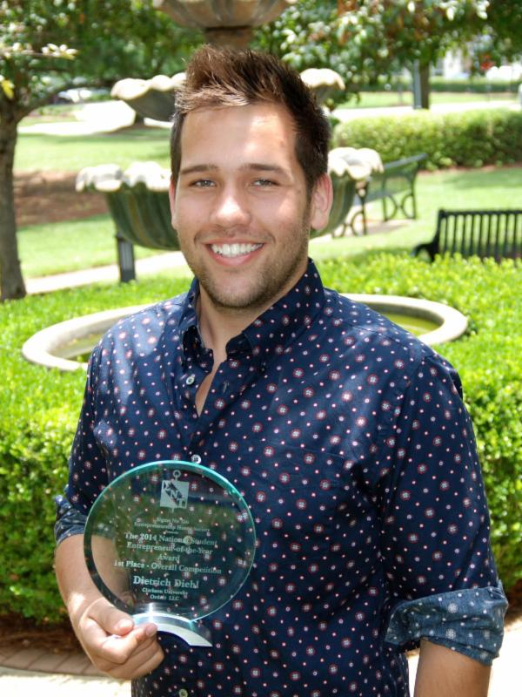
OrdrIT

In 2011, the OrdrIT concept was conceived at Clarkson University. It consists of four student entrepreneurs with various complementary backgrounds. OrdrIT is a mobile ordering platform that simplifies venue operations by enabling spectators to order and pay for concessions/ merchandise from their seats via their smartphones and venue operated E-hawking devices. OrdrIT also enables venues to capitalize on lost revenue opportunities and increase incremental revenues through live time promotions and directly marketing to a captive audience.

OrdrIT's mission is to enhance the spectator experience and increase the bottom-line for venues. The company estimates their target market size to $10 billion in annual concession sales in North America. OrdrIt is currently operating in about 10 venues across the country and is in aiming to triple that number this year. The immediate goal is to secure about 20 Minor League Baseball (Milb) stadiums, to give OrdrIt a total of 30 venues. OrdrIt plans to switch gears and target indoor professional arenas, such as the NBA and the NHL, in the fall 2014.

Tyler Newkirk- Belmont University
1st Runner Up- Overall Competition
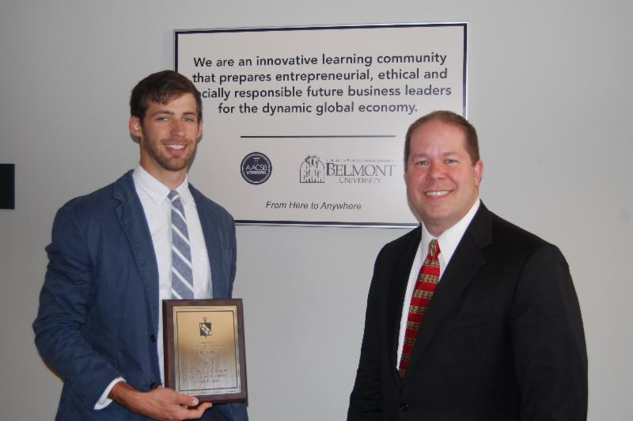
ToCallItHome

Tyler has been inspired to find a profitable way to help adopting families raise money for their adoption campaigns after his family went through the arduous process of adoption. After connecting with the adoption advocates in and around Nashville and meeting several families currently in the process of adopting kids internationally, he was moved with urgency to execute his idea. Tyler believes that his entrepreneurship classes at Belmont University played an important role in building his confidence to pursue a new venture and his ability to judge whether his idea was a good or not.

Tyler researched his social entrepreneurship idea and decided how to best implement it. He chose a crowdfunding platform and helps adoptive families to produce a professonal video in which they explain their heartfelt feelings that led to their decision to adopt. The knowledge that he can both help families grow and help orphans find permanent, loving homes is enough to keep him going each day, regardless of the outcome.

